

## PROJECT REPORT

**On**

**“AUTOMATION SYSTEMS”**

**SESSION 2017-18**

**BY:**

**VAISHNAVI ANAND**

**B.Tech (ECE), 2ND YEAR**

**UNDER THE GUIDANCE OF**

Mr. NAGARAJU ADDU

**SENIOR EXECUTIVE (PD, SLN, OEC,GEC,AP)**

**SIEMENS, KHARGHAR**





**SRM IST/ T&P/IPT/2017-18 23 March 2018**

**CHIEF MANAGER, HR DEPARTMENT**

SIEMENS LIMITED KALWA WORKS

THANE BELAPUR ROAD AIROLI

NAVI MUMBAI -400708

Dear Sir,

**Sub. : Requisition for Internship – Reg.**

Greetings from SRM IST!

SRM Institute of Science and Technology (Formerly known as SRM University) is one of the top ranking universities in India with over 38,000 students and more than 2600 Faculty across all the campus offering a wide range of Undergraduate, Postgraduate and Doctoral Programs in Engineering, Management, Medicine and Health Sciences, and Science and Humanities.

It is our endeavour to have effective industry-institute interaction whereby the students are exposed to the practical nuances through project Internship in organisation of repute like yours.

We request that the below mentioned student(s) may be accorded permission to do Internship during 1ST JUNE TO 1ST JULY in your esteemed organisation.

**STUDENT NAME COLLEGE REG NO DEGREE DEPARTMENT YR**

**1. VAISHNAVI ANAND RA1611004010628 B.TECH. ECE II**

We thank you in anticipation.



**PLACEMENT OFFICER**

# CERTIFICATE

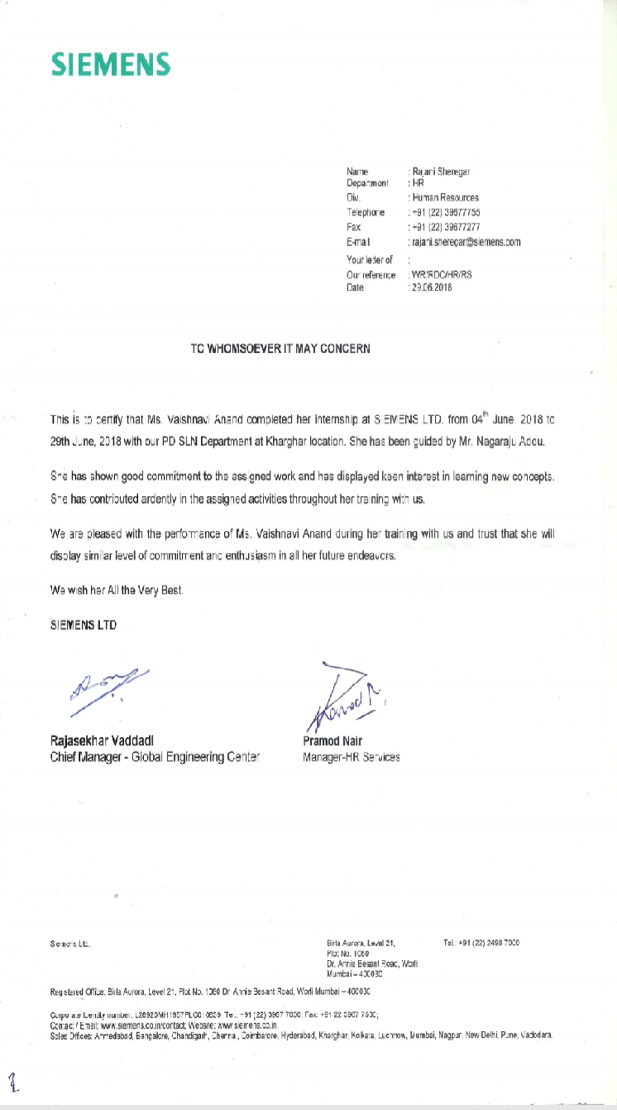

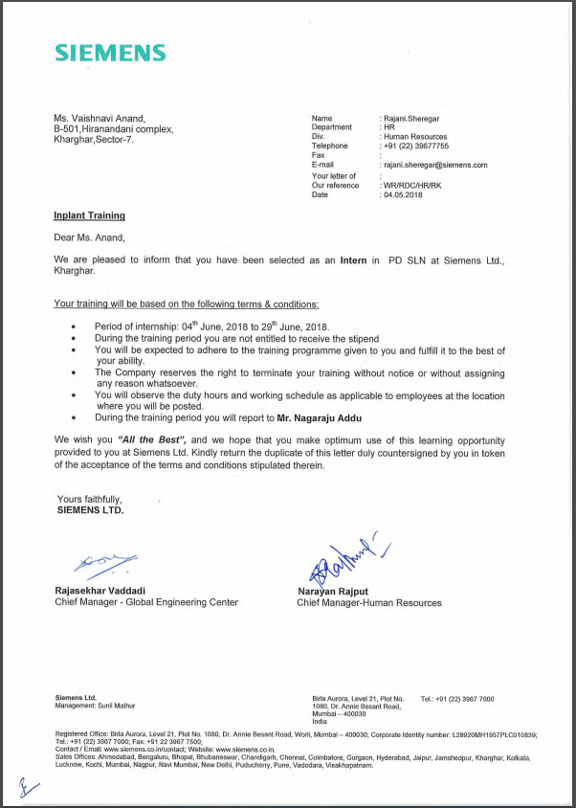

STUDENT’S DECLARATION

I Vaishnavi Anand, hereby declare that the work being presented in this report entitled “Automated Systems” submitted to Shree Ramaswamy Memorial

Institute of Science and Technology (SRM) is an authentic record of my own work carried out under the guidance of Mr.Rajashekhar Vaddadi.

Dated: 22/06/2017 (Vaishnavi Anand)

Btech - ECE

ACKNOWLEDGEMENT

I take this opportunity to express my profound sense of gratitude and appreciation to all those who helped me throughout the duration of this project.

I would like to thank Mr. Rajashekhar Vaddadi for his encouragement, support and providing necessary facilities along with his guidance and expert supervision for this project.

I am truly thankful to the entire Infocom team for their support and timely help

LIST OF CONTENTS

Contents

PROJECT REPORT 1

CERTIFICATE 3

ABSTRACT 10

AUTOMATION SYSTEMS 10

ABOUT SIEMENS 11

OVERVIEW OF THE COMPANY 11

Global Engineering Center (GEC) at Siemens 11

Automation 12

CLASSIFICATION OF AUTOMATION SYSTEM 13

Control of machine 14

Hard wired Relay Logic Control 14

Control Using Logic Gates / Dedicated Electronic Control 15

Programmable Controller (PLC) 16

Racks 17

PSU (Power Supply unit) 18

I/O Cards 18

Motor 19

Communication Processor (CP) 20

Interfacing Modules (IM) 20

Engineering Station 21

Operating Station 21

SOFTWARE 21

Process automation 21

HMI 22

PIPING AND INSTRUMENTATION 23

Bid and Proposal 25

Types of Timer 28

Types of Counters 29

WinCC 30

# ABSTRACT

## AUTOMATION SYSTEMS

**Automation** is the technology by which a process or procedure is performed without human assistance.[[1]](https://en.wikipedia.org/wiki/Automation#cite_note-1) Automation [[2]](https://en.wikipedia.org/wiki/Automation#cite_note-Rifkin_1995-2) or automatic control is the use of various [control systems](https://en.wikipedia.org/wiki/Control_system) for operating equipment such as machinery, processes in factories, boilers and heat treating ovens, switching on telephone networks, steering and stabilization of ships, aircraft and other applications and vehicles with minimal or reduced human intervention. Some processes have been completely automated.

In the simplest type of an automatic [control loop](https://en.wikipedia.org/wiki/Control_loop), a [controller](https://en.wikipedia.org/wiki/Controller_(control_theory)) compares a measured value of a process with a desired set value, and processes the resulting error signal to change some input to the process, in such a way that the process stays at its set point despite disturbances.

# ABOUT SIEMENS

## OVERVIEW OF THE COMPANY

**Siemens**[**AG**](https://en.wikipedia.org/wiki/Aktiengesellschaft) is a German [conglomerate company](https://en.wikipedia.org/wiki/Conglomerate_(company)) headquartered in [Berlin](https://en.wikipedia.org/wiki/Berlin) and [Munich](https://en.wikipedia.org/wiki/Munich) and the largest industrial manufacturing company in Europe with branch offices abroad.

Siemens offers a wide range of electrical engineering- and electronics-related products and services.[[116]](https://en.wikipedia.org/wiki/Siemens#cite_note-reutprof-116) Its products can be broadly divided into the following categories: buildings-related products; drives, automation and industrial plant-related products; energy-related products; lighting; medical products; and transportation and logistics-related products.

Electrification, automation and digitalization are the long-term growth fields of Siemens. In order to take full advantage of the market potential in these fields, Siemens businesses are bundled into nine divisions and healthcare as a separately managed business.

* Power and Gas
* Wind Power and Renewables
* Power Generation Services
* Energy Management
* Building Technologies
* Mobility
* Digital Factory
* Process Industries and Drives
* Financial Services
* [Healthineers](https://en.wikipedia.org/wiki/Siemens_Healthineers)
* Automation and drive system for steel Mills

# 

# Global Engineering Center (GEC) at Siemens

The GEC will help deliver high-quality, end-to-end solutions to Siemens’ Oil and Gas customers worldwide. The GEC will drive customers’ cost competitiveness efforts.

1988 [GEC](https://www.gracesguide.co.uk/GEC) and [Siemens AG](https://www.gracesguide.co.uk/Siemens_AG) set up a jointly held company, **GEC Siemens** plc, to launch a hostile takeover of [Plessey](https://www.gracesguide.co.uk/Plessey_Co). GEC Siemens' initial offer was made on 23 December 1988 valuing Plessey at £1.7 billion. Plessey rejected the offer and it was referred to the MMC. The original proposal envisaged joint ownership of all of Plessey's defence businesses, with [GPT](https://www.gracesguide.co.uk/GPT) and Plessey's North American businesses split in the ratios 60:40 and 51:49 respectively. The level of GEC's involvement in the Plessey defence businesses was not likely to meet with regulatory approval.

1989 After reference to the MMC, in February GEC Siemens announced a new bid. The takeover was completed in September 1989.

The GEC will support Siemens’ oil and gas customers worldwide and strengthen Siemens’ capability to deliver high quality, end-to-end solutions across disciplines such as structural, civil, mechanical, electrical packages, 3D modelling and telecommunications.

The GEC would act as a repository of know-how and experience. It is a natural progression of the centers for oil and gas solutions business already set up in India — at Mumbai and Vadodara — to provide engineering support for automation and electrical tasks.

# 

# Automation

**Automation** is the technology by which a process or procedure is performed without human assistance. Automation is the one which is highly recommended in industries now a days. Automation is the use of various control systems for operating equipment such as machinery, processes in factories, boilers and heat treating ovens, switching on telephone networks, steering and stabilization of ships, aircraft and other applications and vehicles with minimal or reduced human intervention. Some processes have been completely automated.

In the simplest type of an automatic control loop, a controller compares a measured value of a process with a desired set value,and processes the resulting error signal to change some input to the process, in such a way that the process stays at its set point despite disturbances.

## CLASSIFICATION OF AUTOMATION SYSTEM

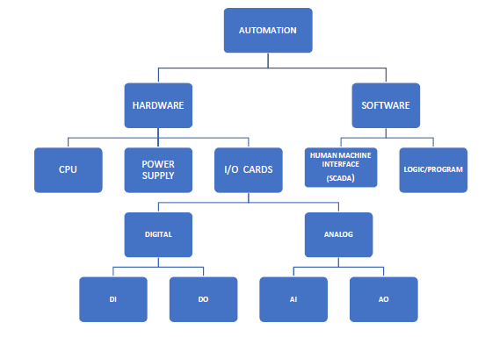

# Control of machine

This can be done in the following four ways:

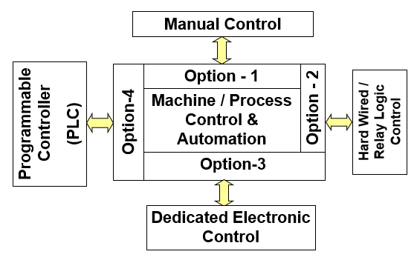

### Hard wired Relay Logic Control

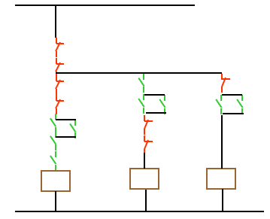

### Control Using Logic Gates / Dedicated Electronic Control

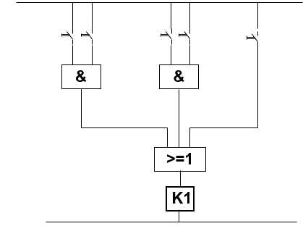

### Programmable Controller (PLC)

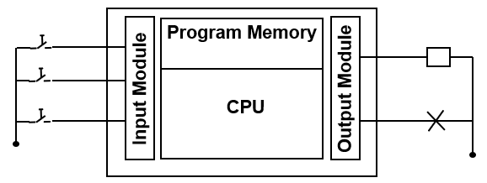

A **programmable logic controller** (PLC) is a miniature industrial computer that contain hardware and software to perform control function. Functions of a PLC are motion control, process control, networking control; distributed control etc. It is a field programmable device. They were first developed in the automobile industry to provide flexible and easily programmable controllers to replace hard-wired relays, timers and sequencers. Since then they have been widely adopted as high-reliability automation controllers suitable for harsh environments. A PLC is an example of a "hard" real-time system since output results must be produced in response to input conditions within a limited time, otherwise unintended operation will result.

A PLC consists of 2 basic sections: Central Processing Unit

(CPU) and the input/output interface system.

**CPU**

The CPU reads input data from connected field devices using its input interfaces and then executes or performs the control, monitor and shutdown operations through the program that has been stored in its memory system. Programs are typically created in the ladder logic and are entered prior to operation. The Siemens CPUs available are of the format 41X.Where X denotes the version of CPU. During the training period, we got an opportunity to see the CPU 417-4 model. Here - 4 signifies the number of interfaces available. The CPU model number is selected depending upon the no. of field, I/O’s available

Out of the many versions of CPUs of Siemens two are S7-400 and S7-300

S7-400 is advanced version of S7-300 PLC. Step 7 software is generally used for S7-300 PLC which acts as engineer station (ES) where logic of PLC is written in ladder logic most preferably. This ES is connected to hardware PLC and the code is uploaded to the hardware and the output is checked. In case of unavailability of hardware one can use PLC online Simulator.

Another software PCS7 is used for S7-400 version which can also be used for S7-300 but the vice-versa cannot take place i.e. one cannot use S7-400 with Step 7.

## Racks

The Rack is the component that holds everything together. Depending on the control system it can be ordered in different sizes to hold the number of modules/CPU.

There are a total of 18 slots in the rack containing CPU. It is split into 2 nos of, 9

slots. The second half is for redundant systems. The first 2 slots of the Rack are

reserved for Power Supply Unit (PSU). The next 2 slots are reserved for the CPU.

The rest of the 5 Racks are reserved for CP cards. The rack containing, I/O modules contains 11 slots plus 2 slots for interfacing modules.

## PSU (Power Supply unit)

The Power Supply plugs into the rack and supplies a regulated DC power to other

modules that plug into the rack. Most popular power supplies work with 120V AC or 24 VDC sources.

## I/O Cards

There are 4 types of I/O cards-

· Analog Input (AI)-It converts a voltage or current (a signal that is between 4-

20mA) into a digitally equivalent number that can be understood by CPU.

· Digital input (DI)-It handles discrete devices which gives a signal that is either

on or off such as pushbutton, limit switch, sensors or selector switches.

· Digital output (D0)-It turns a device on or off such as lights, LED’s, motors, and relays.

· Analog output card (A0)-It will convert a digital number sent by CPU to voltage or current values. Typically, the output signals range from 0-10 VDC or 4- 20mA and are used to drive mass flow controllers, pressure regulators and position controls.

All the analog or digital devices are categorized as input or output depending on Distributed Control System (DCS)

AI, AO: 4-20 mA; DI, DO: 24 V or 0 V

## Motor

Start and Stop Commands: DO

Start and Stop Feedback: DI

In general,

AI to DCS from transmitter (say) AO from controller on DCS

DI is in from of 0 or 1 coming from a switch (say) to DCS

DO: An output of 24 V DC or 0 V DC comes from DCS to solenoid (say)

Examples:

DI: Switches

AI: From transmitters

DO: To control digital output devices (having 2 statuses: ON/ OFF)

AO: Control valve partial opening or closing as per required

Number of IO counts define system configuration

IO count generates PO (Process Objects): number of objects required for controller action.

A motor is a PO. We know that a motor has 2 DI and 2 DO, so 10 motors contain 20 DI and 20 DO but they correspond to 10 PO only.

Now let us see the flow of signals between field instruments (instruments in field under supervision) and control room (where the PLC, HMI panels are located)

Field instruments generate soft signals (AI or DI) in single pair cables. N number of cables come from N number of instruments. A junction box generates a multi pair cable where all N cables are carried to the terminals of panel consisting of PLC, ET 200 racks (containing Interphase modules (IM), Power supply (PS) cards, IO cards). After the execution of logic as per code in PLC through output cards output commands (AO or DO) are sent back to instruments via Junction boxes.

Each I/O card has specific number of channels (equal to number of I/O counts)

AI and AO: 8/16 channels

DI and DO: 16/32 channels

Hence if IO count is 50 AI we can use seven 8 channel cards or four 16 channel cords.

ET 200 racks are of two types generally ET 200 M (commonly used) and ET 200 ISP (used for specific purposes)

## Communication Processor (CP)

They are modules used for special communication protocols. The standard CP 443-1 is used to connect the SIMATIC S7-400 to Industrial Ethernet in addition to the communication to further Ethernet collaborates the CP takes on the function of a PROFINET- IO controller. As PROFINET Controller, the CP in the machine also controls distributed I/O modules.

## Interfacing Modules (IM)

They are used for communicating information between I/O Cards and CPU.

Peripherals connected to a computer need special communication links for interfacing them with the central processing unit. The purpose of the communication link is to resolve the differences that exist between the central computer and each peripheral. The major differences are:

· Peripherals are electromechanical and electromagnetic devices and their manner of operation is different from the operation of the CPU and memory, which are electronic devices. Therefore, a conversion of signal values may be required.

· The data transfer rate of peripherals is usually slower than the transfer rate of the CPU, and consequently, a synchronization mechanism may be needed.

## Engineering Station

PC station with PCS 7 Engineering Toolset for centralized plant-wide engineering:

· Configuration of the hardware

· Configuration of the communications networks

· Configuration of continuous and sequential process sequences using

standard tools

· Configuration of discontinuous process sequences (batch processes) with SIMATIC BATCH

· Configuration of route controls with SIMATIC Route Control

· Operator control and monitoring strategies

· Compilation and downloading of all configuration data to all target automation system (AS), operator station (OS), BATCH station (BATCH) and Route Control station

## Operating Station

PC station with human-machine interface is used for operating and monitoring of PCS 7 plant in process mode. An operator station can be configured as a single station or multiple station system with OS client / OS server architecture. It is also possible to use a central archive server (CAS) on a separate PC station. The archive server is a node on the terminal bus.

# SOFTWARE

Automation can be classified into Process and Industry automation.

## Process automation

It consists of continuous chemical processes with analog measurement signals and control. Parts of the equipment are in explosive atmosphere. It has a relatively slowresponse time. It uses typical actuator, pumps, and control valves. PID control loops are used.

Process automation consists of Distributed Control System (DCS)

A distributed control system (DCS) is a specially designed automated control system that consists of geographically distributed control elements over the plant or control  area. In DCS each process element or machine or group of machines is controlled by a dedicated controller. DCS consists of many local controllers in various sections of plant control area and are connected via a high-speed communication network.

Distributed individual automatic controllers are connected to field devices such as sensors and actuators. These controllers ensure the sharing of gathered data to other hierarchal controllers via different field buses. Different field buses or standard communication protocols are used for establishing the communication between the controllers. Some of these include Profibus, HART, arc net, Modbus, etc.

DCS is most suited for large-scale processing or manufacturing plants wherein many continuous control loops are to be monitored and controlled. The main advantage of dividing control tasks for distributed controllers is that if any part of DCS fails, the plant can continue to operate irrespective of failed section.

## 

## HMI

This is used to operate, monitor, and control plant parameters. It can be a PC or any other monitoring device that has a separate software tool on which operator can view process parameter values and accordingly to take control action.

**Working and operation of DCS**

Sensors sense the process information and send it to the local I/O modules, to which actuators are also connected to control the process parameters. The information or data from these remote modules is gathered to the process control unit via field bus.

If smart field devices are used, the sensed information directly transferred to process control unit via field bus.

The collected information is further processed, analysed and produces the output results based on the control logic implemented in the controller. The results or control actions are then carried to the actuator devices via field bus. The DCS configuring, commissioning and control logic implementation are carried at the engineering station. The operator can view and send control actions manually at operation stations.

DCS system from Siemens is Simatic PCS7.

# PIPING AND INSTRUMENTATION

We even worked on Piping and Instrumentation Diagram of a sludge tank and concluded number of AI, AO, DI, DO leaving the manual local valves

A **piping and instrumentation diagram** (**P&ID**) is a detailed diagram in the [process industry](https://en.wikipedia.org/wiki/Process_industry) which shows the [piping](https://en.wikipedia.org/wiki/Piping) and [vessels](https://en.wikipedia.org/wiki/Pressure_vessel) in the process flow, together with the [instrumentation](https://en.wikipedia.org/wiki/Instrumentation) and control devices.

Superordinate to the *piping and instrumentation flowsheet* is the [*process flow diagram*](https://en.wikipedia.org/wiki/Process_flow_diagram)*(PFD)* which indicates the more general flow of plant processes and equipment and relationship between major equipment of a plant facility.

P&IDs are interactive reports in the P&ID module. Symbol bars and tools are available to you on P&IDs for drawing. Preconfigured objects are provided for you in a library. These objects may represent:

● Pipes

● Components

● Functions

Pipes

Pipes are connections that are available both on the P&ID and in the Navigator. They possess separate technical data and transport certain properties of their associated objects.

Signal lines

Signal lines are objectless connections. They are divided into measuring lines and process lines.

Components

The term component includes the following objects:

● Equipment Equipment separates pipes. Example: pumps, vessels, heat exchange units

● Fittings Fittings are components of equipment. Example: Column packaging, tank agitators

● Mounts Example: Brackets

Pipe parts Pipe parts are all parts used for the pipe. They are installed in pipes. P&ID Operation Operating Manual, 04/2015, A5E32035600-AD 15 Example:

● Flange

● T-piece (separates sections)

● Reducers (section separating)

● Valve Fittings Connector parts

Functions

Functions constitute an interface between the P&ID area and the I&C area. They possess a number of automatic functions.

P&ID graphical symbols P&ID graphical symbols are graphic additions to a drawing. These objects can neither be ordered nor can they be evaluated in lists of objects. However, unlike P&ID labeling symbols, an object is created in the Navigator for P&ID graphical symbols.

# Bid and Proposal

Bid proposal-

In procurement of Automation system, the Bid and Proposal (B&P) are a firm's plan (proposal) and proposed cost (bid) for fulfilling the conditions outlined in a Request For Quotation (RFQ) or other information gathering or supplier contact activity.

Prebid:

Pre-Bid meetings hold a very important place in the procurement domain. Pre- bid meetings are usually held if mentioned in the tender document during the preparation of Bid Proposal. The basic purpose of such meeting is to clarify any concerns the bidder may have to the bidding document, the scope of work and other details. When they are held for consulting services they are known as Pre-Proposal meetings

Pre-Bid Meetings are important because they provide guidance to the details of the document to the interested bidders. Interested bidders can request for clarification after the invitation for bid or request for Proposal. The Pre-Bid meeting is held within that period. These meetings are formal and results are made available in writing to all prospective bidders that are interested in the documents, which are called MOMs (Minutes of Meetings).

Pre-Bidding meeting are conducted either by the procurement authority or the authority issuing the tender agreed upon a date/ time/ and Location.

Whoever qualifies for pre-bid/technical part of a bid will be eligible for the firm bid.

Firm bid:

In firm bid the numbers of bidders are short listed. The client/customer will have firm bid meeting in which they will negotiate the cost, inclusions and exclusions part will be decided.

**Programming Languages**

**AND, OR Gate Logics**

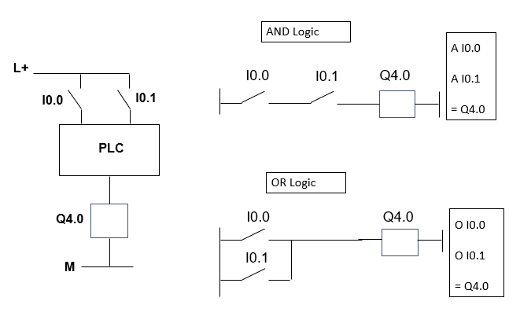

# Types of Timer

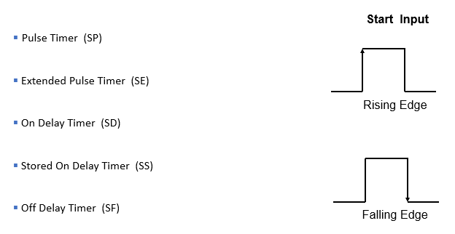

**Details of Timer block**

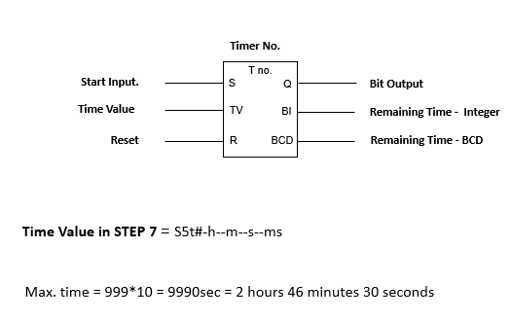

**Timing diagram**

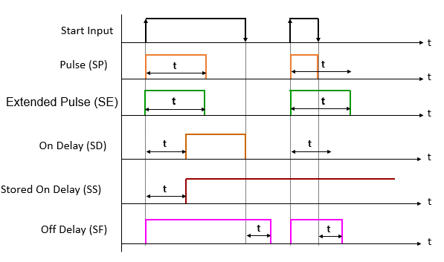

# Types of Counters

1. Count UP (CU)
2. Count Down (CD)
3. Count UP/Down (SC**)**

**Details of Counter block**

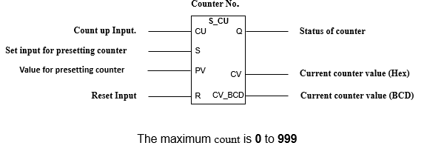

WinCC

is a modular system. WinCC is used to visualize the process and configure a graphic user interface. We will use the user interface to operate and observe the process. WinCC offers the following possibilities:

● WinCC allows us to observe the process. The process is displayed graphically on the screen. The display is updated each time a status in the process changes.

● WinCC allows us to operate the process. For example, we can indicate a setpoint from the user interface or we can open a valve.

● WinCC allows us to monitor the process. An alarm will automatically signal in the event of a critical process status. If, for example, a predefined value is exceeded, a message will appear on the screen.

● WinCC allows us to archive the process. When working with WinCC, process values can either be printed or electronically archived. This facilitates the documentation of the process and allows subsequent access to past production data.

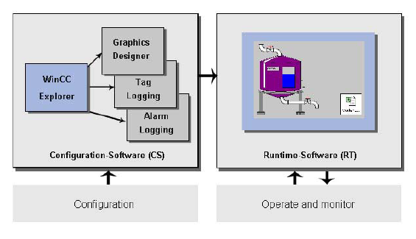

**Tags in Win CC**

The tags in WinCC represent either real values or internal values. The internal values are calculated or simulated within WinCC. WinCC manages all tags in the "Tag management" editor.

**Process Tags**

The connecting link for the exchange of data between WinCC and the automation systems are the external tags. Each external tag in WinCC corresponds to a certain process value in the memory of one of the connected automation systems. External tags are therefore referred to as process tags.

In Runtime, the process values of the process tags are determined and entered by WinCC.

In WinCC, we can also determine the values for the process tags. These values are transferred to the automation system via the stipulated channel. The automation system controls the process accordingly.

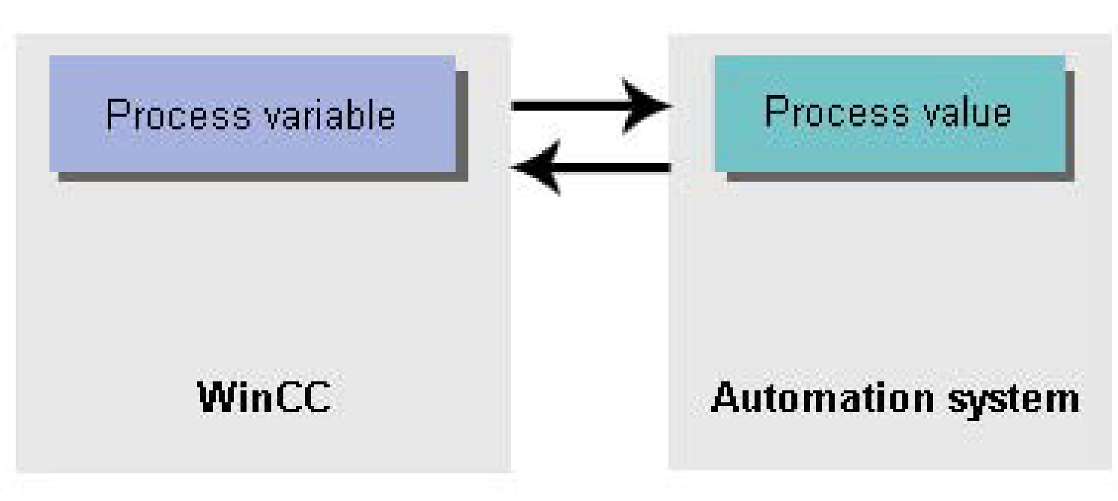

**Internal tags**

WinCC also has internal variables. These tags do not have a process link and only carry values within WinCC.

**Tag groups**

The tag groups are components of the "Tag management" editor. The tag groups are used to organize tags clearly.

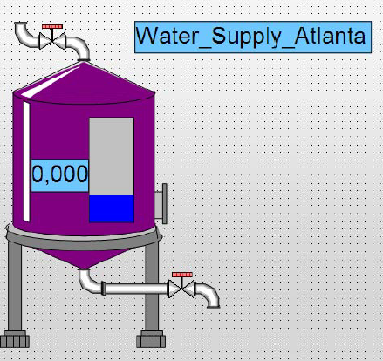

A sample object tank taken in screen designing.

We worked on control system design of a water reservoir being built by Siemens in Qatar by linking tags and screen designing. The logic is written mostly as per ladder logic and inputs, outputs are linked to the screen of the operator in control room using tags so as to enable screen operate as touch panel. This entire concept of HMI and fault diagnosis can be put up under one heading named SCADA.